

Covid-19 Protocols

Version 1.0

Sept 10 2020

As approved by HRSC COVID-19 Committee

Dear HRSC Families, Coaches and Affiliates,

It is exciting for us to be able to be days away from taking the ice again after such a long break. Hats off to everyone in our province for doing such a great job in flattening the curve. As we have heard many times over the last few weeks and months, without everyone’s diligence and commitment; we would not be where we are today.

We are very fortunate to have been included in Stage 2 of the Provincial Relaunch. With this privilege comes responsibility.

Together, HRSC will do our part to keep our forward momentum by following the protocols and guidelines laid out in this package. At the end of this document, there is an acknowledgment form that confirms that you have reviewed our protocols and agree to follow them.

Please print and sign this form and bring it with you to your first session.

Below is a checklist of important forms and lists that need to be reviewed prior to your first and/or every session:

1. Acknowledgement of Agreeance of HRSC COVID-19 Protocols
2. SKATE CANADA ASSUMPTION OF RISK AND WAIVER
3. Daily Screening upon arrival at facility and session
4. Contract Trace Log (this applies to anyone who will be in attendance ) including spectators

If you have any questions regarding this package, please feel free to contact any of the following:

Ashlee Folkersen highriverskatingclub@gmail.com

Christianne Dahlman cdahlman@live.ca

Liat Kobetitch (Director of Coaching HRSC) rlkobetitch@hotmail.com

Thank you so much for your patience throughout this pandemic. It’s been a challenge getting and more importantly, thank you for your commitment to getting us and keeping us back on the ice.

Sincerely,

Ashlee Folkersen

President of HRSC

**PROTOCOLS AND PROCESSES**

**(as per requirements and guidelines of Skate Canada: Alberta-NWT/Nunavut)**

## CLUB DESIGNATE

Our club designate for COVID-19 Protocols and Execution of Protocols is:

Ashlee Folkersen

All Waivers, Acknowledgement Forms, Contact Trace Forms, verbal daily screening and so forth, will go through Ashlee. You must see Ashlee, Christianne Liat or Shaelyn prior to the start of any session, whether on ice, or dry land.

**RELATING TO CLUB OPERATIONS**

## CSO-001 COMPLIANCE WITH REGULATIONS

Maximum number of participants at the large ice level is 50. This is broken down to maximum of 45 skaters, 4 coaches and 1 music operator.

At this time, the large ice allows 100 spectators at which HRSC is responsible for monitoring.

Skaters must be registered and be confirmed by Liat Kobetitch or Ashlee Folkersen prior to arriving to ensure our capacity guidelines are met and not exceeded.

## CSO-002 COMPLIANCE WITH SECTION PROTOCOLS AND WAIVER

All participants MUST sign and hand in the SKATE CANADA ASSUMPTION OF RISK AND WAIVER.

All forms are ONLY to be handled, filled out and maintained by our designate.

All participants **MUST** be screened daily by our designate (another responsible party may conduct this screening if trained by our designate prior to first shift).

Completed forms to be handled and maintained only by our designate. Completed forms will be filed and kept securely for a minimum of 4 weeks (as required by protocol) and then destroyed.

**CSO-003**

## COVID-19 EDUCATION

Coughing and Sneezing

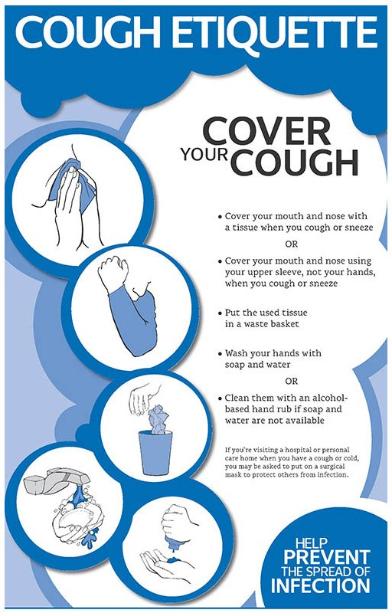

Physical Distancing

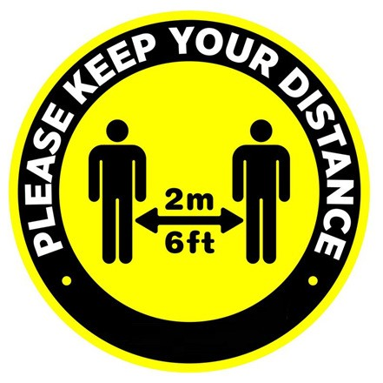

Handwashing

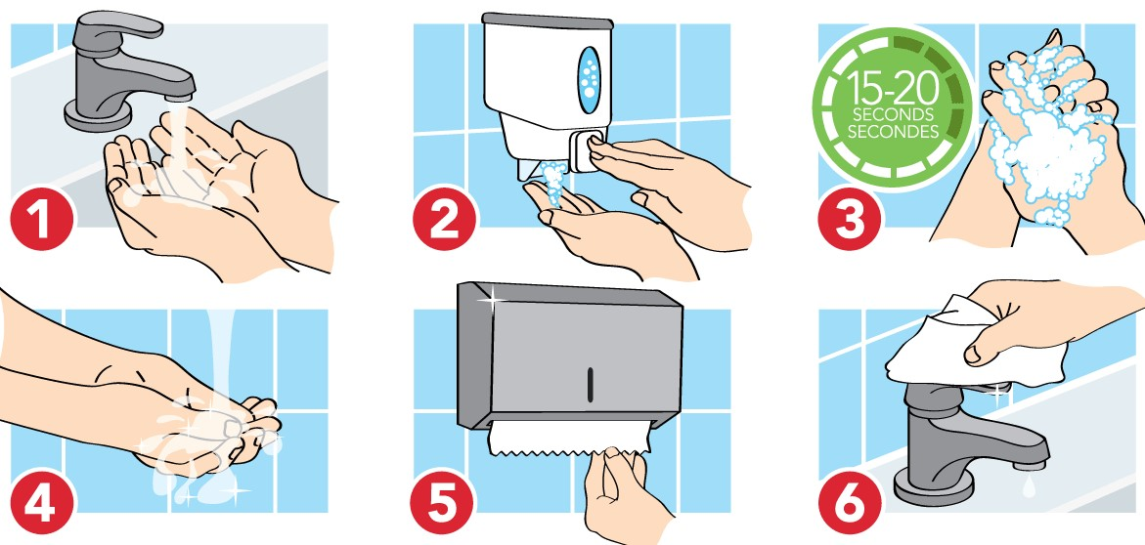

Proper Donning and Doffing (putting on and off)

**CSO-004**

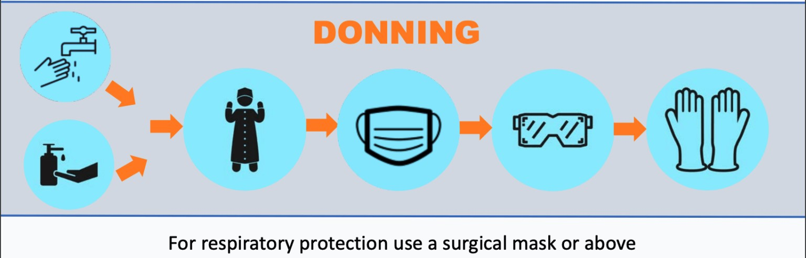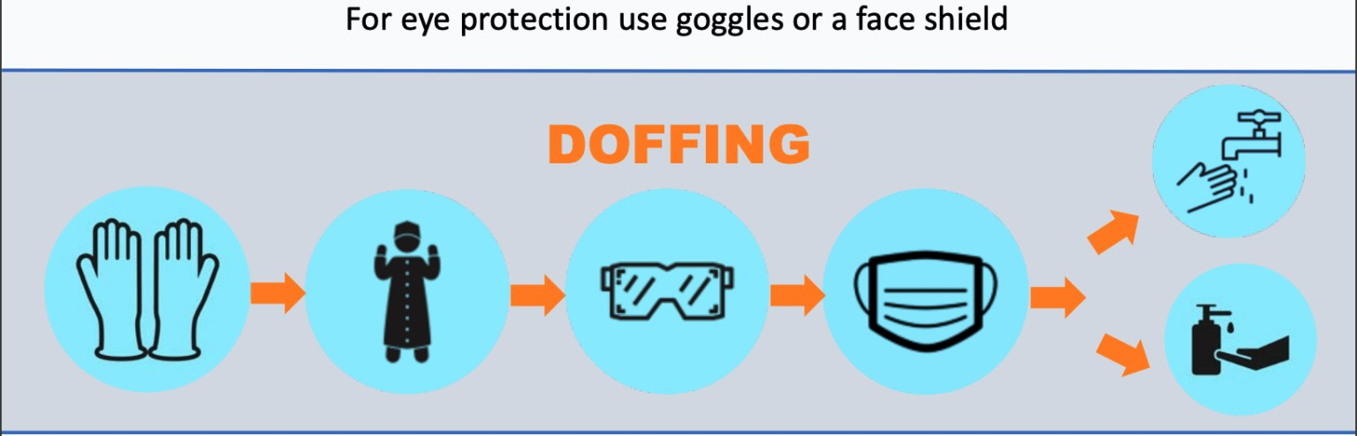

## COVID-19 RESPONSE PLAN

If a participant is unwell DO NOT come to the session. 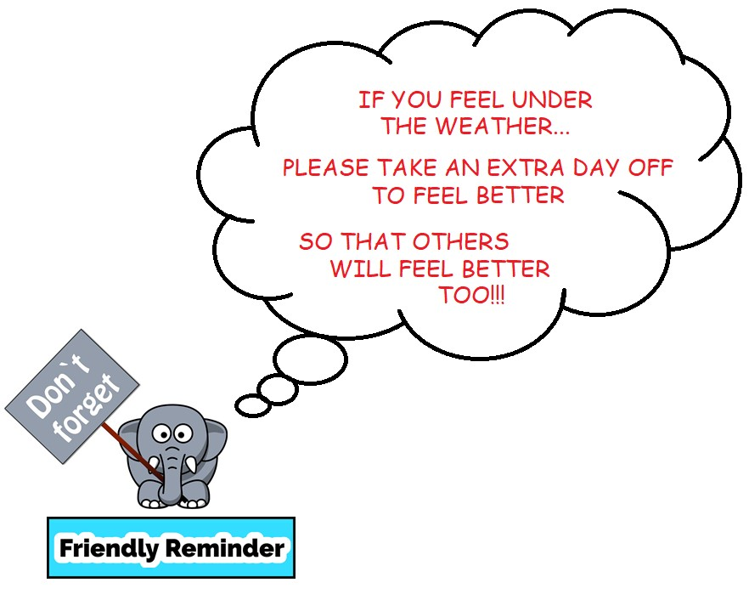

If a participant begins to feel unwell during a session, they MUST report to Liat Kobetitch or Ashlee Folkersen **IMMEDIATELY**. They will be moved and placed into a designated area (penalty box), proper PPE is to be worn and parent or guardian will be called. Participant will remain in this designated area until they are picked up. If the participant is an adult or has driven themselves, they are to go home if able. Participants showing or feeling any symptoms, please call 811 and do as directed. If the participant is directed to get tested for COVID-19 they are NOT to return until a negative test result is given to them by a medical professional. Participant MUST also inform Ashlee Folkersen Or Liat Kobetich that they have been instructed to do so, so it can be properly documented.

If the participant is not instructed to be tested for COVID-19, then they must not return until at least 24 hours has passed since they felt unwell.

## * One person testing positive for COVID-19 is considered a case *

**\*\*\* Two People testing positive for COVID-19 is considered an OUTBREAK \*\*\***

Again… If a participant has been sent for testing, they are NOT permitted to return until a negative result has been given by a medical professional.

If a participant tests positive for COVID-19, it MUST be reported Ashlee Folkersen. Ashlee will inform AHS and follow their direction. All parties recorded on the Contact Trace Logs will be notified by phone (First and Last names as well as phone numbers MUST be recorded on Contact Trace Logs).

Bi-Weekly COVID-19 Newsletters will be sent out by the COVID-19 Committee to all members, with updates and information as new information becomes available.

**CSO-005**

## FACILITY COORDINATION

Participants are not to enter or proceed past entrance until verbally screened by our designate (and all required signed forms are handed in).

All parties are to maintain appropriate physical distancing of 2m / 6 feet at all times.

Only use entrance and exit doors and traffic flow as marked and identified by facility.

Try not to touch door handles, rails or other surfaces if possible, use elbows to open automatic doors or use motion detected entrances when possible.

Water fountains are only available to fill bottles.

**WASHROOMS ARE ONLY AVAILABLE IN THE LOBBY** not available in change rooms.

HRSC is encouraging wearing face coverings upon entrance to the building as well as in the dressing rooms. Coverings can be removed prior to entering ice surface.

**DRESSING ROOMS ARE TO BE USED FOR PUTTING SKATES ON ONLY.** Changing of clothes is not permitted. Loitering is not permitted during ice sessions. We encourage arriving to the arena completely ready for the ice no earlier than 15 minutes prior to ice time. Skates on when possible.

Max capacity for dressing rooms (large ice) is 10 people.

Max capacity for change rooms (small ice #1 an #2) is 8 people

There is to be NO sharing of food, water bottles or any other personal property.

**CSO-006**

## CLUB STORAGE

Any club property will be managed and maintained by the appropriate individuals. Ashlee Folkersen will maintain the PPE Kit and Forms/Info Binder. Liat Kobetich will maintain required coaching items. Club props, coaching items, ipod, etc. will be properly sanitized after each session.

**CSO-007**

## FIRST AID/EMERGENCIES and PPE KIT

HRSC will maintain and have on hand, a PPE kit. This Kit will contain masks, gloves, sanitizer, face shield(s) and a list of contents.

If there is an injury or emergency, Liat Kobetich or other Coach will be responsible for the participant until they are handed off to a parent or guardian in designated area (time keepers box or time keeper hallway). Music operator will maintain distance but keep eyes on the injured or unwell person.

PARENTS/GUARDIANS are not to step foot on the ice in the event of an emergency unless approved by one of the coaches. Person attending to injured participant is to wear a mask and gloves.

**CSO-008**

## SELF-SCREENING MEASURES

All participants MUST self-screen at home (see checklists) and must not attend if:

* They are experiencing any COVID-19 symptoms such as fever, cough, have difficulty breathing or other symptoms identified by health experts
* They have returned from travel outside Canada, must quarantine for 14 days
* Have been in contact with someone with COVID-19 in the past 14 days

There is a self-checklist for skaters and other parties within this package. Please review this checklist every day!

**CSO-009**

## SCREENING OF INDIVUALS

All participants, coaches, individuals, etc, must be verbally screened by our designate every time they arrive to the facility.

**CSO-010**

## TRACKING OF PARTICIPANTS

* Contact Trace Logs for ANYONE staying longer than 15 minutes (dropping off) must be completed for every training activity and be available to be accessed quickly to ensure efficient contact tracing.

As Contact Trace Logs contain personal information, the logs will be maintained only by our designate.

Contact Trace Logs MUST be kept for a minimum of 4 weeks. HRSC will keep the logs for at least the required time and then destroy.

**CSO-011**

## MULTIPLE FACILITIES

Coaching and/or skating at multiple facilities in the same day is discouraged and should be avoided.

If it cannot be avoided, additional enhanced hygiene should be practiced. This includes changing clothing and masks between facilities.

It is the responsibility of the participant to inform both clubs of participation in both places.

**CSO-012**

## TRAVEL

Travel should align with Provincial Guidelines.

Carpooling or joint transportation should be kept to members in the same household or cohort families to maintain compliance with physical distancing.

**CSO-013/CSO-014**

## SCHEDULING/SESSION REGISTRATION

Participants MUST be registered prior to arriving at their session to ensure proper scheduling and capacity maintenance.

If participants do not arrange their attendance ahead of time and obtain approval from registration and Liat Kobetitch, they may not participate.

**CSO-016/CSO-016**

## PARTICIPANT COMPLIANCE/COMPLIANCE ENFORCEMENT

*** All participants and clubs are required to acknowledge adherence to the Skate Canada: Alberta NWT/Nunavut Protocols and Guidelines and adhere to Provincial and Municipal Protocols.

If a participant or parent/guardian or coach is aware of these Protocols and Guidelines NOT being adhered to, you can submit a complaint to AHS online or leave a message at 1-833-415-9179

* The Section office should be notified (or copied) in writing of the Provincial or Health Concern

Any participant (or parent/guardian) should notify the Section Office of non-adherence to Skate Canada

Guidelines or Skate Canada: Alberta NWT/Nunavut protocols and guidelines

* non-compliance may result in the suspension of sanctioned activities, programming, or participation in a sanctioned activity and could jeopardize insurance coverage

**RELATING TO PROGRAMMING**

**CSP-001**

## SIZE OF GROUPS

Maximum number of participants on a session will be 25. This is dependant on Provincial Guidelines and subject to change.

HRSC is allowing up to 20 skaters, 4 coaches and 1 music operator per session. Spectators are not included in this number and must stay away from ice level (rink side).

The Safe Sport Rule of 2 for coaches applies at all times regardless of size of group.

**CSP-002**

## PROGRAMMING

StarSkate, CanPower, Parent and Tot, Synchronized Skating and Pairs skating are permitted in Phase 2 as revised by Skate Canada.

**CSP-003**

## PAIRS AND ICE DANCE

Pairs/Ice Dance teams are to follow the guidelines below:

* Only skaters who reside in the same household or are in the same cohort family/team are permitted to be within 2m of each other and may have contact on or off the ice during the session
* Both skaters must sanitize their hands immediately before and immediately after each session
* Skaters must respect physical distance guidelines within non-ice areas (while putting on skates, entering and exiting, etc)
* Skaters should also respect physical distance requirements when conducting warm-ups and cool downs (this is different than dry land training and is for the peace of mind of all participants and individuals)

**CSP-004**

## SYNCHRONIZED SKATING

Teams (and team members) must comply with the following:

* Synchro team members must form and stay within a cohort/bubble group in order to be permitted to have contact on the ice
* Crossover cohort teams is NOT permitted (team member cannot have a synchro cohort team, and a soccer cohort team for example)
* Freeskating as a single is permitted if you are part of a Synchro cohort
* All team members must sanitize their hands immediately before and immediately after each session
* All warm-ups and dry land training should comply with physical distancing - Maximum capacity restrictions on ice still apply

**CSP-005/CSP-006**

**ASSESSMENT DAYS/COMPETITIONS AND GATHERINGS**

Assessments are now permitted and will take place as per the revised protocol.

Competitions and simulations have been revised and not now permitted as per protocol.

**RELATED TO SKATING/TRAINING ACTIVITIES**

**STA-001**

**ENTRY AND EXIT**

All participants shall follow entry and exit guidelines and traffic flow as indicated by facility.

**STA-002**

## PHYSICAL DISTANCING

All participants are required to maintain a physical distance of 2m (6 feet) at all times with other participants, coaches and individuals etc.

While on the ice:

* All coaching should be done with verbal cues
* There should be NO physical contact unless medical attention is required

Any use of technology (Ipads, devices, IPod etc.) may not have common touch! ONLY one operator.

HRSC will require a music operator per session to ensure compliance.

**STA-003**

## SPECTATORS/PARENTS

Spectators are only permitted if they are a parent or guardian accompanying a minor (person under the age of 18) and must remain in a designated area.

All Spectators are required to follow all guidelines laid out in this package as well as Provincial/Municipal and facility guidelines.

All Spectators MUST wear a mask while in the building.

NO public spectators will be permitted.

**STA-004**

## PERSONAL HYGIENE

* Individuals shall wash or sanitize their hands upon entry into facility
* Club employees and volunteers must wear a mask while in public areas and frequently wash/sanitize their hands
* PPE (personal protective equipment) must be worn according to Provincial, Municipal and Facility Guidelines
* Avoid touching door handles, gates, benches and other common surfaces
* Personal hygiene etiquette MUST be practiced at all times (any tissues used, coughed or sneezed into must be placed immediately into the garbage or sealed in a Ziploc and taken home
* There shall be NO spitting
* All training clothes, gloves, water bottles, etc, must be kept clean. It is requested that all clothing and items be washed and equipment be sanitized before re-entering the facility

**STA-005**

## PERSONAL PROTECTIVE EQUIPMENT (PPE)

Coaches must wear a face shield or mask when physical distancing is not possible.

Gloves must be worn and are to be washed daily (this also applies to Volunteers).

Skaters are not required to wear a face mask but may choose to do so. Public Health recommends that masks NOT be worn by athletes performing intense physical activity. Gloves must be worn and are to be washed daily.

PPE requirements apply to those attending to injured or unwell participants as per previous protocol.

**STA-006**

## PERSONAL ITEMS

Skaters are to enter the building dressed and ready for training, wearing their skates and carrying only their *necessary* personal items in 1 bag.

Skaters are to wear clean clothes every day.

Food items are NOT to be shared.

Tissues must be disposed of immediately into a garbage bin or sealed in a Ziploc and taken home.

**STA-007/STA-008**

## DRESSING ROOMS/WASHROOMS

Dressing rooms will only be used for putting on skates. No changing of clothes is permitted. Skaters MUST arrive dressed and ready to train.

Max number of people in change room’s large ice is 10. Small ice #1 and #2 is 8 people.

Dressing rooms will not be available for loitering.

Washrooms are NOT to be used as change rooms.

Washrooms available in lobby only

**STA-009/STA-010/STA-011/STA-012**

## WARM-UP AND COOL DOWN/SKATES ON-OFF/ENTRY AND EXIT FROM ARENA/ENTRY AND EXIT FROM ICE SURFACE

Whenever possible, warm-ups and cool downs (stretch) will be done outside.

Participants and individuals may enter the building not more than fifteen (15) minutes prior to the start of their training and must leave the building immediately when their session is finished.

Our designate will ensure these protocols are being followed, and you must not enter the building until you have been instructed to proceed by our designate.

**STA-013**

## MUSIC/VIDEO/MOBILE DEVICES AND OTHER TECHNOLOGY

Coaches may have their own devices for video and instructional purposes. These devices cannot be touched by any other individual.

Viewing of devices is permitted but physical distance MUST be maintained.

Music devices are only to be used by coaches or assigned music playing volunteer.

**STA-014**

**ON-ICE COACHING**

Coaches may coach from the boards or on the ice. Physical distancing MUST be maintained at all times.

**STA-015**

## HARNESS

Skater or skater parent must be able to strap skater into harness. Coaches may not assist in getting a skater into the harness.

**DON’T FORGET TO PRINT AND SIGN:**

**ACKNOWLEDGEMENT OF AGREEANCE TO FOLLOW THESE PROTOCOLS**

**SKATE CANADA ASSUMPTION OF RISK AND WAIVER**

**SKATER CHECKLIST**

## Before you leave home

 DO NOT leave home if you are feeling unwell or showing signs of COVID-19 Symptoms (Fever, Cough, Shortness of Breath, Sore Throat or Runny Nose)

 Check for facility / arena closures

 Eat before you come, if you take food please ensure it is self-contained, do not share

 thoroughly wash your hands with soap and warm water

 thoroughly wash water bottles with soap and warm water

 thoroughly wash training clothes and accessories including gloves, hard guards, blade rag etc.  Pre-Register for your session

 Warm up at home, if whether prevents warming up outside

 Use the washroom

 Sign **Skate Canada Assumption of Risk and Waiver** either online or bring a signed copy to the arena prior to or at the first session you are registered for

## Arrival at the Arena

 Arrive at facility no more than 15 minutes prior to scheduled ice session

 Warm up outside if possible, maintaining physical distance of 2m

 Enter through established entrances and follow signs

 Wash your hands with soap & water or sanitize using hand sanitizer

 Respect social distancing guidelines at all times

 prior to first session submit signed **Skate Canada Assumption of Risk and Waiver** in designated area (if not completed online)

 **Contact Tracing Attendance** Form must be completed daily prior to entering facility

 DO NOT share water bottles or personal items

 arrive no earlier than 5 minutes to the side of the rink and stay in designated area

## During floods

 Wash your hands with soap & water or sanitize using hand sanitizer immediately after getting off the ice

 Adhere to club or skating school procedures for flood breaks and in between sessions

 arrive no earlier than 5 minutes to the side of the rink and stay in designated area

## After on-ice Training is complete

 Wash your hands with soap & warm water or sanitize using hand sanitizer immediately after getting off the ice  Leave the facility immediately following on-ice training

 Exit through established exits

 Cool down outside the building if possible, while maintaining physical distance of 2m. Cool down at home if weather prevents cooling down outside

 thoroughly wash water bottles with soap and warm water

thoroughly sanitize all training clothes and accessories including phones, gloves, hard guards, blade rag etc.

**STAFF / COACH / CHOREOGRAPHER / VOLUNTEER CHECKLIST**

## Before you leave home

 DO NOT leave home if you are feeling unwell or showing signs of COVID-19 Symptoms (Fever, Cough, Shortness of Breath, Sore Throat or Runny Nose)

 Check for facility / arena closures

 Eat before you come, if you take food please ensure it is self-contained, do not share

 thoroughly wash your hands with soap and warm water

 thoroughly wash water bottles with soap and warm water

 thoroughly wash all previously-worn clothes and accessories

 Ensure PPE is readily available: (mask, gloves (mandatory), medical gown (if available), protective glasses (optional)

 Consider bringing personal hand sanitizer

 Use the washroom

 Sign **Skate Canada Assumption of Risk and Waiver** either online or bring a signed copy to the arena prior to or at the first session you are coaching

 Confirm skater attendance, as required

## Arrival at the Arena

 Enter through established entrances and follow signs

 Wash your hands with soap & water or sanitize using hand sanitizer

 Respect physical distancing guidelines at all times

 prior to first session, submit signed **Skate Canada Assumption of Risk and Waiver** in designated area (if not completed online)

 **Contact Tracing attendance** Form must be completed daily prior to entering facility

 DO NOT share water bottles or personal items

 Confirm your students have completed and submitted the Skate Canada Assumption of Risk and Waiver and have received verbal health screening and have registered for Contact Tracing attendance

Arrive no earlier than 15 minutes to the side of the rink and stay in designated area

 Consider wearing PPE (masks, gloves) at all times and have readily available in the case of an emergency

(Injured skater)

## During floods

 Wash your hands with soap & warm water or sanitize using hand sanitizer immediately after getting off the ice  Adhere to club or skating school procedures for flood breaks and in between sessions

 Maintain Physical Distancing at all times

 arrive no earlier than 15 minutes to the side of the rink and stay in designated area

## After on-ice Training is complete

 Wash your hands with soap & warm water or sanitize using hand sanitizer immediately after getting off the ice

 Leave the facility immediately following on-ice training

 Exit through established exits

 thoroughly wash water bottles with soap and water

thoroughly sanitize all arena clothes and accessories including phone, gloves, hard guards, blade rag etc.

**HRSC COVI-19 OUTBREAK PROTOCOL**

The purpose of the Outbreak protocol is to provide a framework to follow for effective control measures.

Early detection of symptoms will facilitate the immediate implementation of effective control measures. In addition, the early detection and immediate implementation of enhanced cleaning measures are two of the most important factors in limiting the size and length of an outbreak.

A “participant” includes a club or skating school employee, coach, choreographer, volunteer, official, skater or parent / spectator.

**An “outbreak” is two or more cases; a “case” is a single case of COVID-19.**

1. If a case of COVID-19 or outbreak is reported. HRSC will immediately report it to the facility(s) and report it to AHS. HRSC may modify, restrict, postpone and/or cancel activities.

1. If a participant reports they are suspected or confirmed to have COVID-19 and have been at the facility, HRSC will report to the facility immediately so enhanced cleaning measures can be put in place to reduce the risk of transmission. HRSC will also: a) Advise individuals to:
   1. Self-isolate
   2. Monitor their symptoms daily, report respiratory illness and not to return to activity for at least 14 days following the onset of fever, chills, cough, shortness of breath, sore throat and painful swallowing, stuffy or runny nose, loss of sense of smell or taste, headache, muscle aches, fatigue and loss of appetite
   3. The Participant will not be permitted to return to the facility until they are free of the COVID- 19 virus as verified by a medical professional.
   4. Use the Alberta Health COVID-19 self-assessment tool to help determine if further assessment or testing for COVID-19 is needed

Individuals can contact 8-1-1 if further health advice is required and 9-1-1 if it is an emergency

Individuals can learn more about symptoms and how to manage a patient at home by accessing the following Alberta Health Services links:

https://www.albertahealthservices.ca/topics/Page17026.aspx https://www.albertahealthservices.ca/topics/Page16997.aspx#sign

1. In the event of a suspected case or outbreak of influenza-like-illness, immediately report and discuss the suspected outbreak with the Medical Health Officer (or delegate) at your local health authority. Implement your Illness Policy and your enhanced measures.

If we are contacted by a medical health officer in the course of contact tracing, we will fully cooperate with local health authorities.

### **SKATE CANADA: ALBERTA-NWT/NUNAVUT ILLNESS POLICY**

The purpose of the Section Illness policy is to provide clubs and skating schools in the Section with a framework to follow for effective control measures.

A “participant” includes a club or skating school employee, coach, choreographer, volunteer, official, skater or parent / spectator.

1. **Inform an individual in a position of authority (coach, club administrator) immediately** if, you feel any symptoms of COVID-19 such as fever, chills, cough, shortness of breath, sore throat and painful swallowing, stuffy or runny nose, loss of sense of smell, headache, muscle aches, fatigue and loss of appetite.

1. **Assessment** 
   1. Participants must have a daily verbal screening for symptoms upon arrival at the entrance of the

Facility

* 1. Administrators/coaches will visually monitor participants to assess any early warning signs as to the status of their health and to touch base on how they are regarding their personal safety throughout the workday/practice/activity
  2. If Participants are unsure please have them use the Alberta Health COVID-19 self-assessment tool

1. **If a Participant is feeling sick with COVID-19 symptoms**
   1. They should remain at home and contact Health Link at 811
   2. If they feel sick and /or are showing symptoms while at work/practice/activity, they should be sent home immediately and have them contact 811 or a doctor for further guidance
   3. Facility must implement Rapid Response Plan including:
      * 1. Immediate isolation of the symptomatic participant from others, including arrangement for safe travel home (e.g., no public transit)
        2. Consideration of suspension or temporary cancellation of the event
        3. Cleaning and disinfecting of all equipment and surfaces that may have come into contact with the symptomatic participant
        4. Performance of hand hygiene by remaining participants
   4. No Participant may participate in a practice/activity if they are symptomatic

1. **If a Participant tests positive for COVID-19**
   1. The Participant will not be permitted to return to the workplace/practice/facility until they are free of the COVID-19 virus as verified by a medical professional
   2. Any Participants who work/practice closely with the infected participant will also be removed from the workplace/practice/facility for at least 14 days to ensure the infection does not spread further
   3. Close off, clean and disinfect their work/practice/facility area immediately and any surfaces that could have potentially be infected/touched
   4. If any participant tests positive, the club/skating school must inform the Alberta-NWT/Nunavut Section Office of the test positive case by emailing info@skateabnwtnun.ca

1. **If a Participant has been tested and is waiting for the results of a COVID-19 Test** 
   1. As with the confirmed case, the Participant must be removed from the workplace/practice/facility
   2. The Public Health Agency of Canada advises that any person who has even mild symptoms to stay home and contact Health Link at 811
   3. Other Participants who may have been exposed will be informed and removed from the workplace /practice /activity for at least 14 days or until the diagnosis of COVID-19 is ruled out by health authorities
   4. The workspace/practice/activity space will be closed off, cleaned, and disinfected immediately and any other surfaces that could have potentially been infected/touched

1. **If a Participant has come in to contact with someone who is confirmed to have COVID-19** 
   * 1. Participants must advise their coach/club administrator if they reasonably believe they have been exposed to COVID-19
     2. Once the contact is confirmed, the Participant will be required to follow the direction of Alberta Health Services
     3. The workspace/activity area will be closed off, cleaned, and disinfected immediately and any other surfaces that could have potentially been infected/touched

1. **Quarantine or Self-Isolate if:** 
   * 1. Any Participant who has a member of their household who has travelled outside of Canada and has experienced any symptoms identified on the verbal health screening questionnaire within the last 14 days is not permitted to enter any part of the facility and must quarantine and self-isolate
     2. Any Participant with any symptoms of COVID-19 is not permitted to enter any part of the facility and must quarantine and self-isolate
     3. Any Participant from a household with someone showing symptoms of COVID-19 is not permitted to enter any part of the facility and must quarantine and self-isolate

Any Participant who is in quarantine or self-isolating as a result of contact with an infected person or in families who are self-isolating, is not permitted to enter any part of the facility

ACKNOWLEDGEMENT OF AGREEANCE

OF

HRSC COVID-19 PROTOCOLS

I acknowledge that I have read and agree to the Protocols and Guidelines set forth in the HRSC COVID19 Protocols Document.

Name of Participant: _________________________ Date of Birth (D/M/Y): __________________

Participants Signature: _________________________

Parent/Guardian Name(s): ___________________________/_______________________________

Parent/Guardian Signature(s): ___________________________/_______________________________

Date (D/M/Y): ________________________________

